**TRAINING ASSIGNMENT**

**(8th  JUNE 2022)**

NAME – ROHIT ARORA ROLLNO – DXC-262AB-1209

BATCH – DXC-262-ANALYTICS-B12-AZURE COMPANY – DXC TECHNOLOGY

EMPLOYEE DOMAIN – AZURE ANALYTICS TRAINER NAME – MR. AJAY KUMAR

DATE OF SUBMISSION – 8th JUNE 2022 NO.OF QUESTIONS: 10

1. Explain the steps with screenshots how to create Blob storage in Azure cloud?

Ans) to create blob storage (Also known as Storage account) in azure cloud we have to follow the following steps

Step-1 :

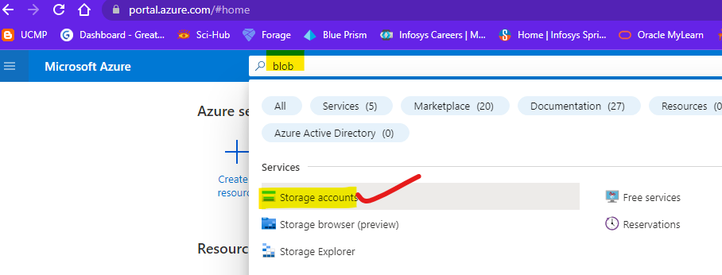

Step-2:

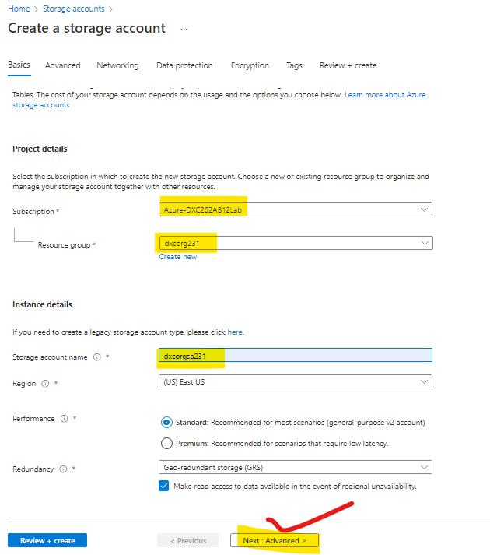

Step-3:

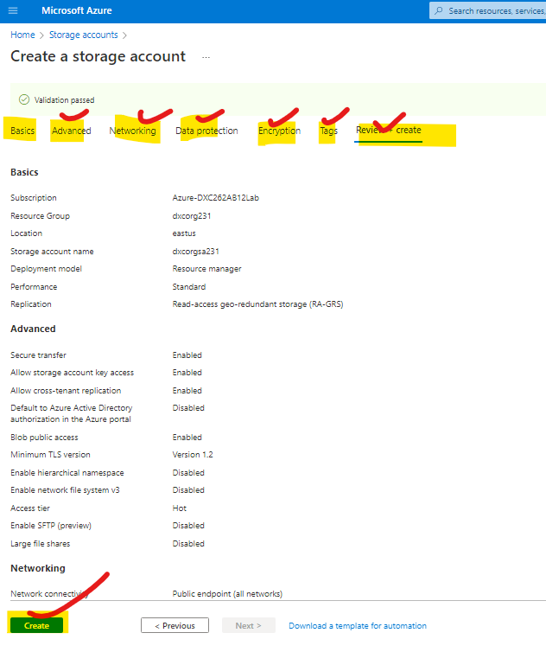

Step-4:

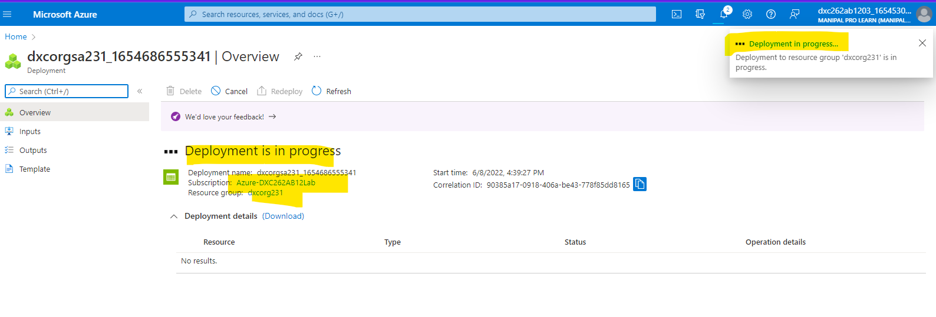

Step-5: The storage Account is created successfully.

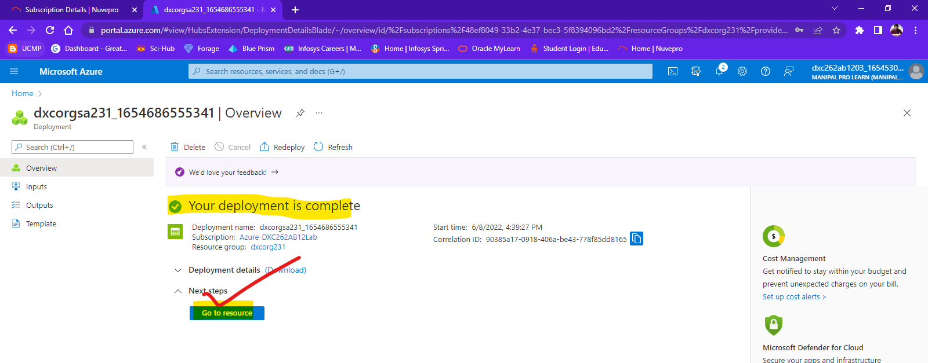

2. Explain the steps with screenshots how to create Virtual machine & how to connect from  
(i) Local Computer - CMD method ?  
(ii) Using Azure cloud Shell?  
(iii) Also using Azure Bastion ?

Ans) we can create virtual machines in azure by following the three method

**Ans: Step 1:** Login to Azure and click on “Virtual Machine”.

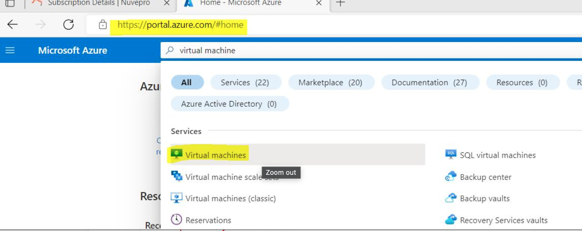

**Step 2:** Click on “create” and then click on “Azure Virtual Machine” to create a Virtual Machine.

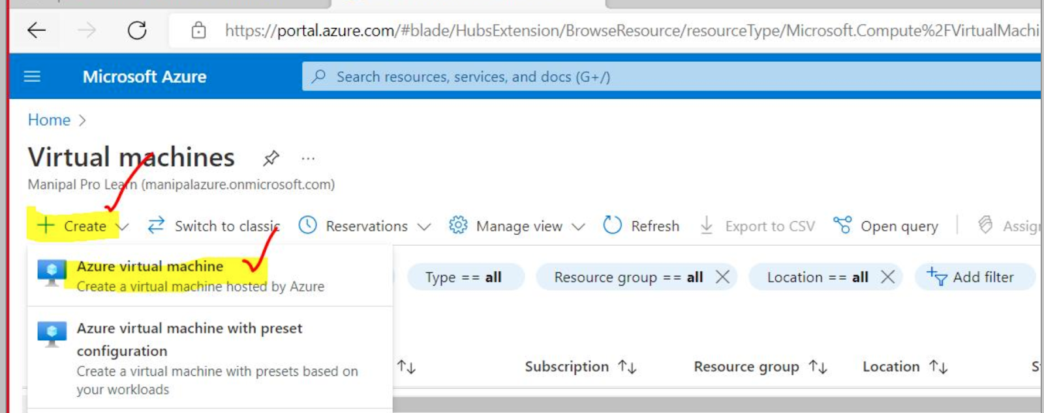

**Step 3:** Complete all the required fields and click on “create” after reviewing to deploy a virtual machine.

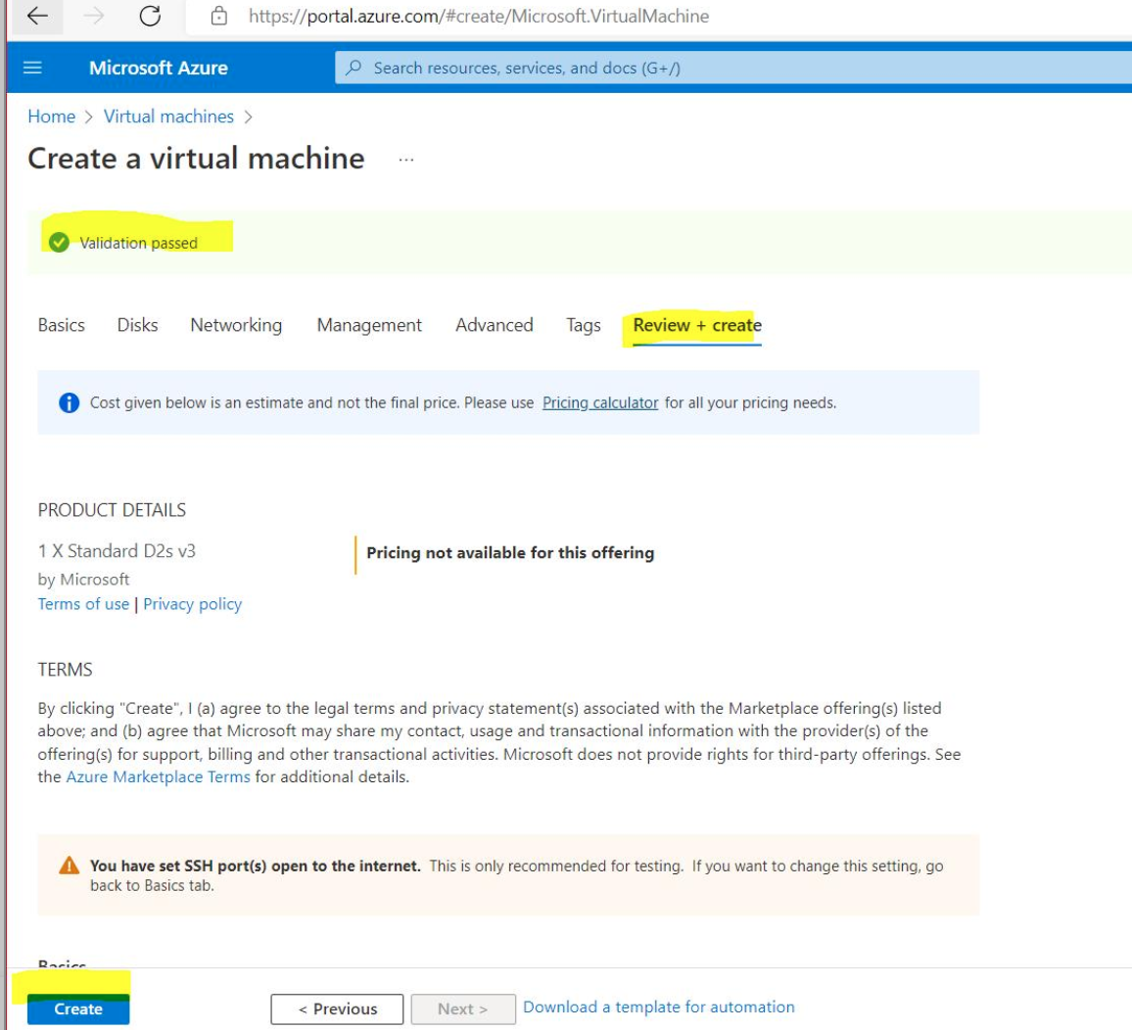

**Step 4:** Generate new key pairs.

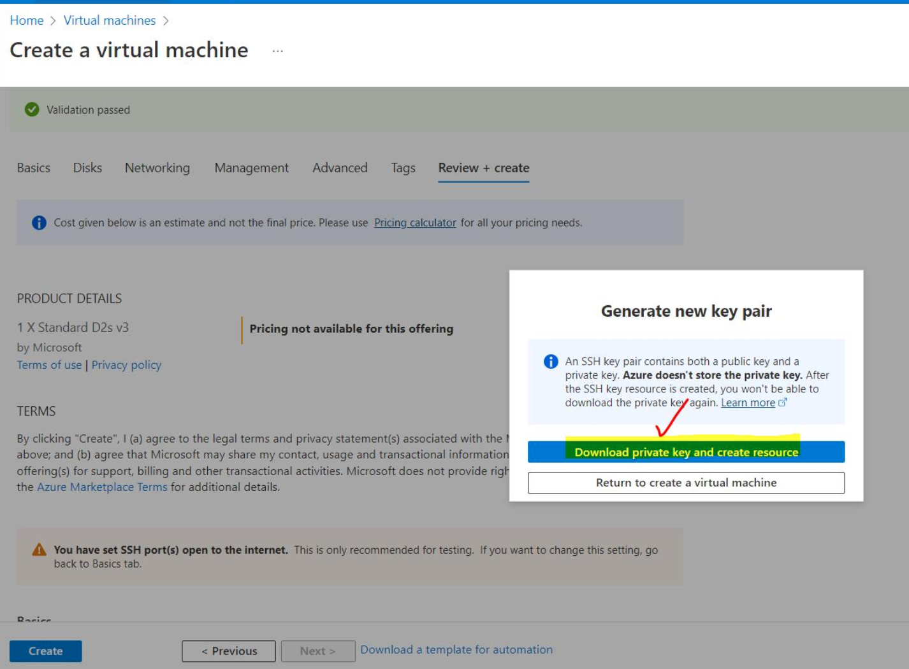

**Step 5:** Connect to a virtual machine using either of the three methods.

**(i) Local Computer - CMD method:** connect using ssh.

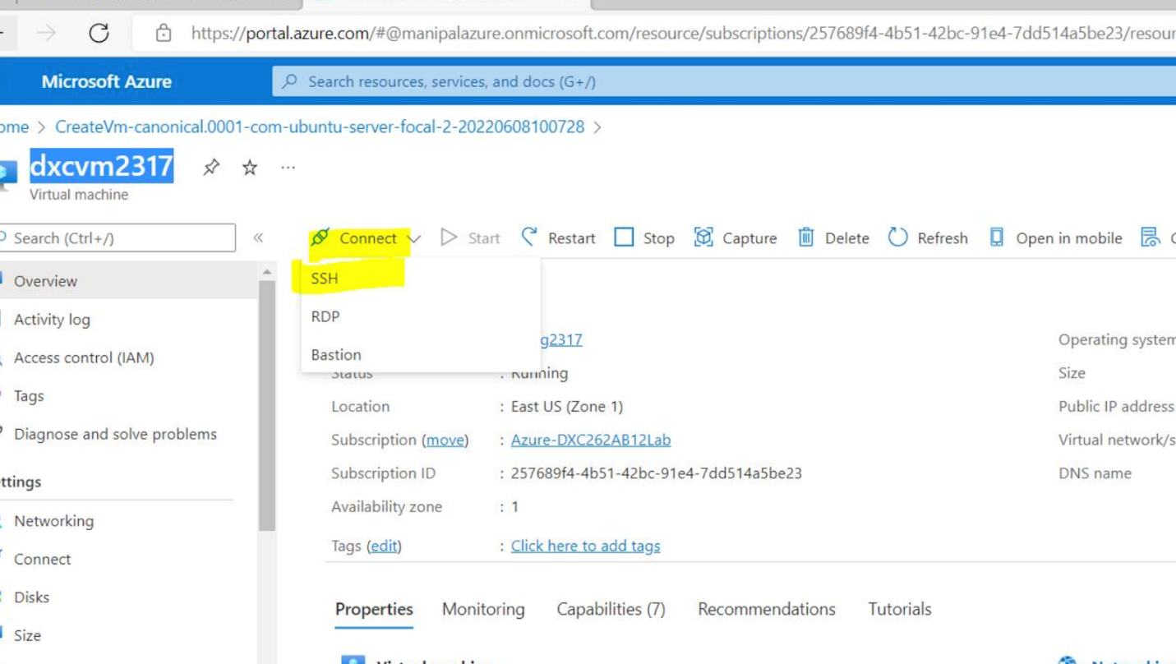

To connect with VM run the key path in the command prompt.

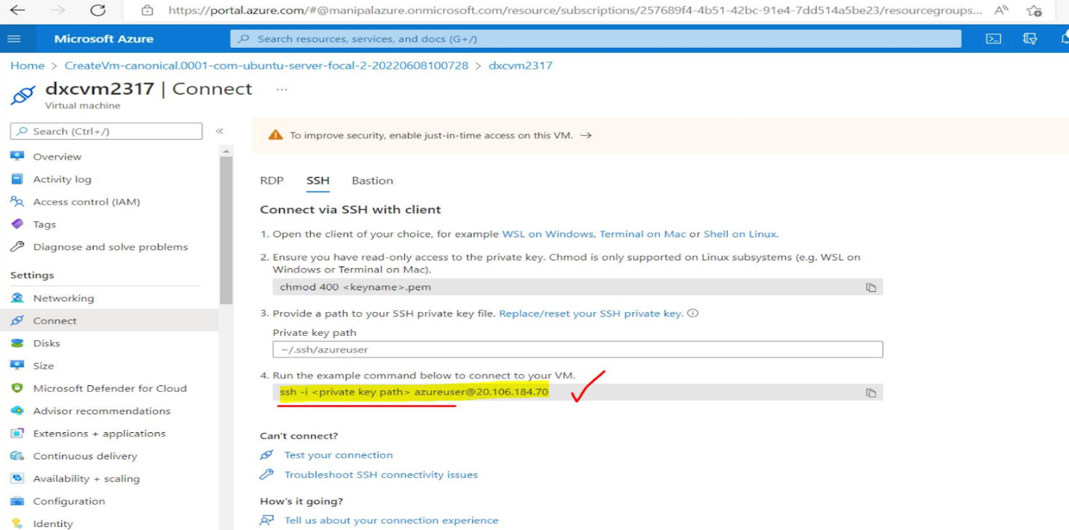

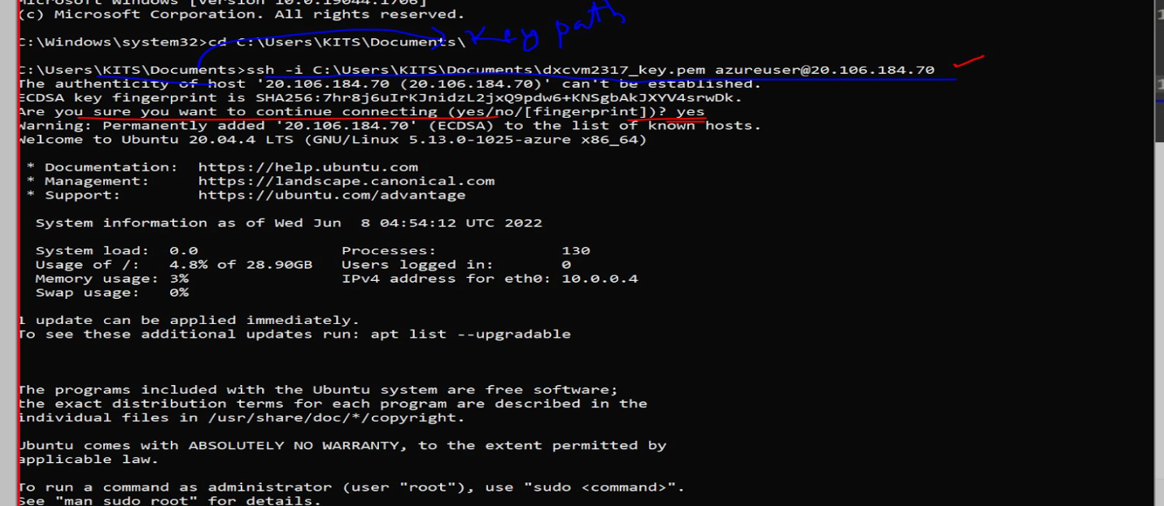

**(ii)Using Azure cloud Shell:** Click on CLI/PS to connect to VM using cloud shell.

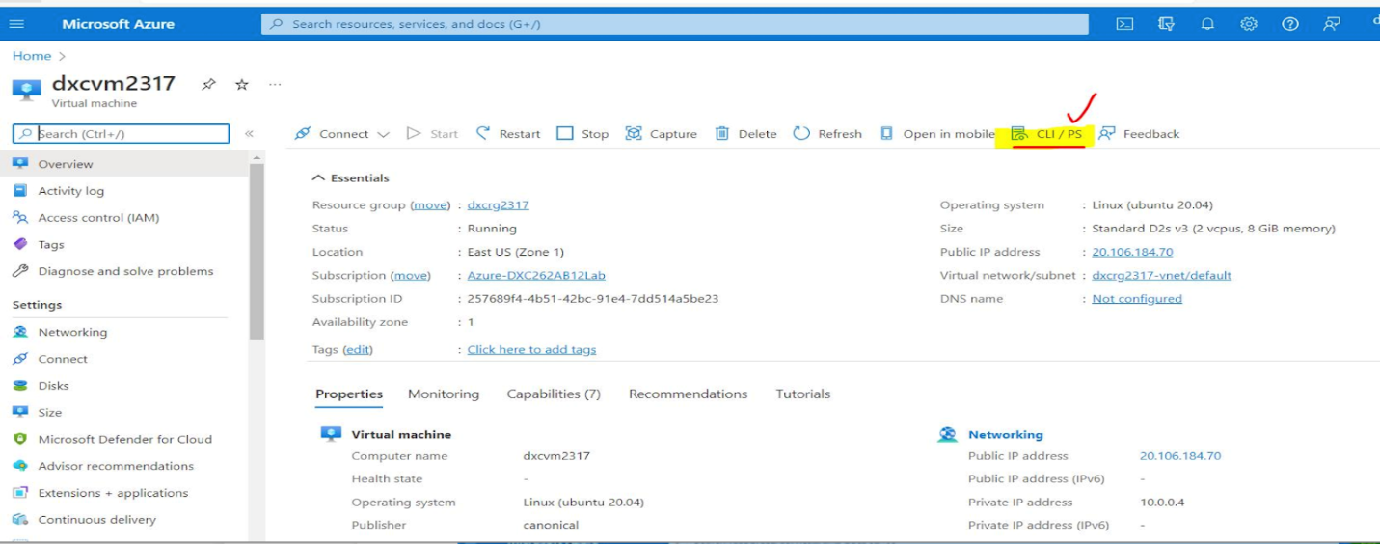

Click on the icon beside the search bar to open Azure Cloud Shell.

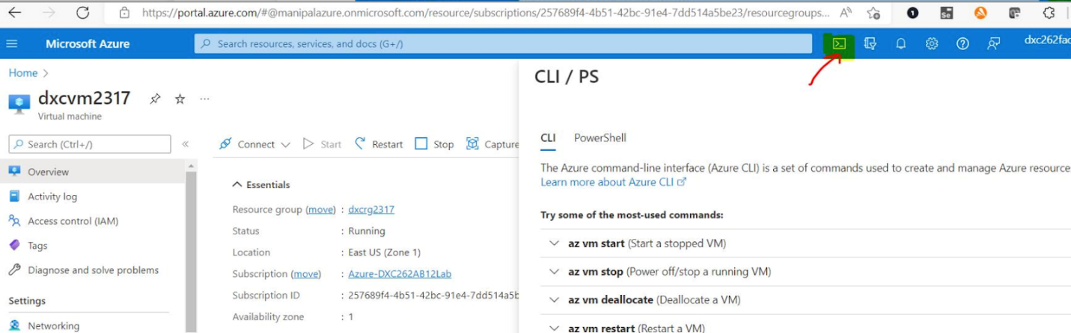

Now click on “bash” to connect to your virtual Machine.

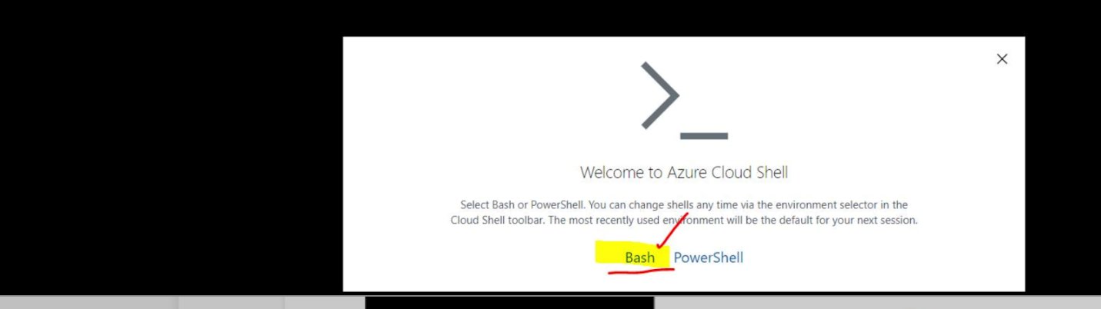

Now create storage as shown in the below screenshot.

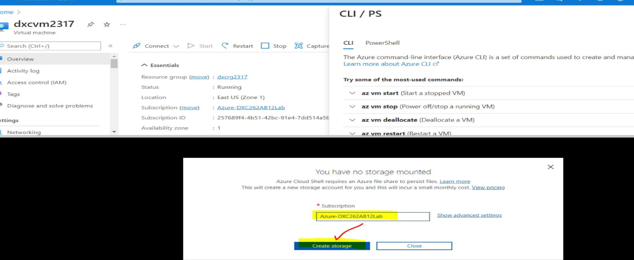

Now to start the vm use the azvm start command as shown.

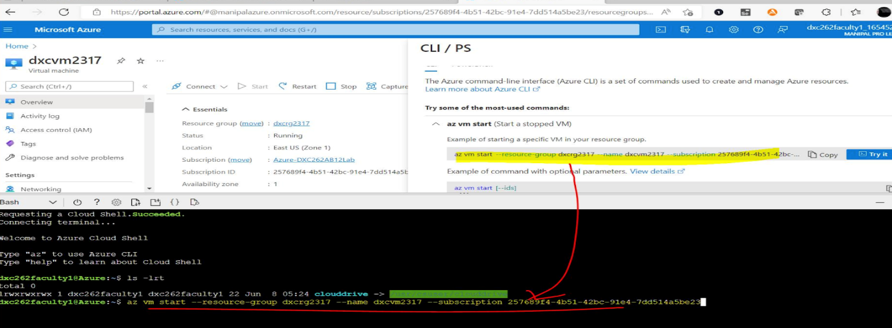

**(iii) Also using Azure Bastion:**

Click on connect and select “bastion” to create a virtual machine using Azure Bastion.

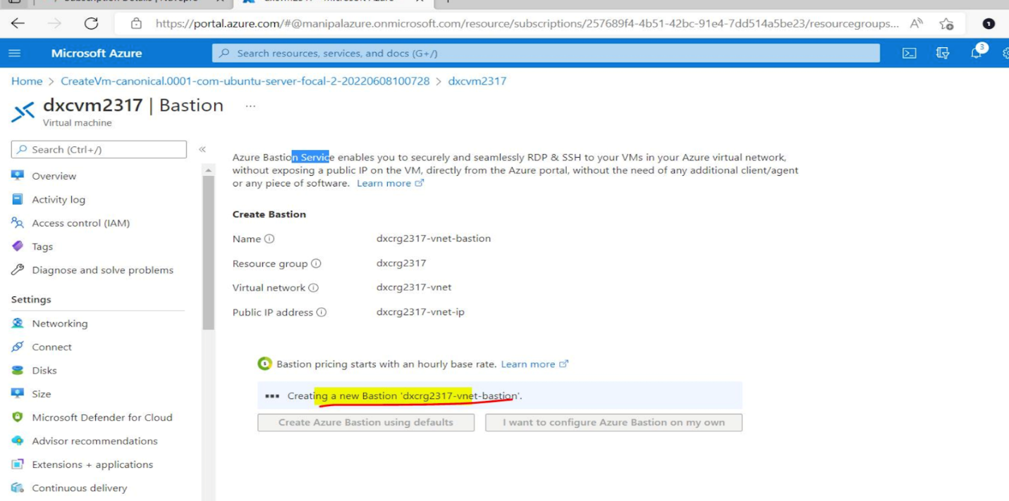

3. Explain the steps with screenshots how to create Data factory ?

Ans) These are the following steps to create Data factory

Step-1: search for data factory in search bar

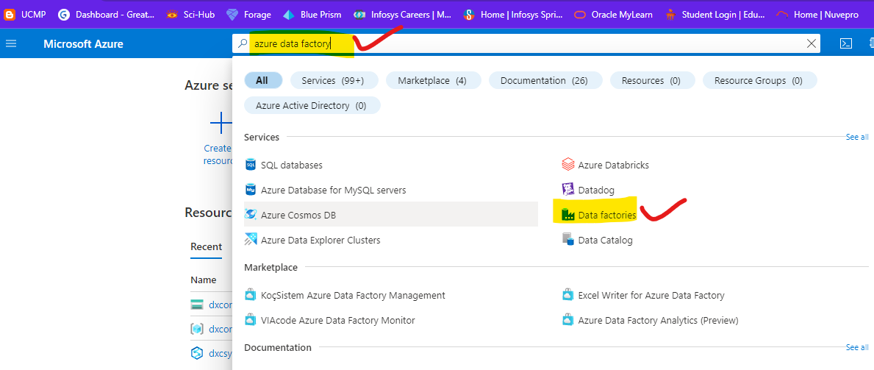

Step-2: click on create button

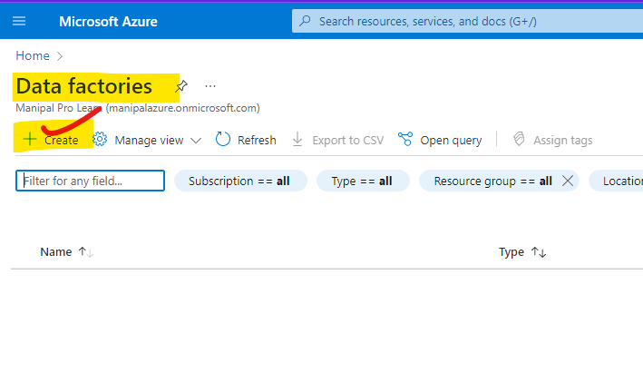

Step-3:

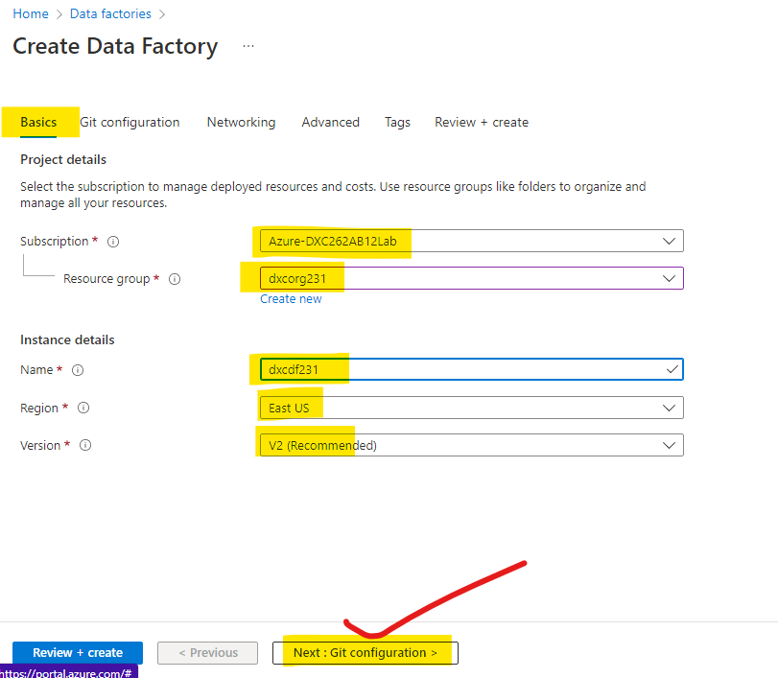

Step-5: set all configurations and there is no need to update at last review and create

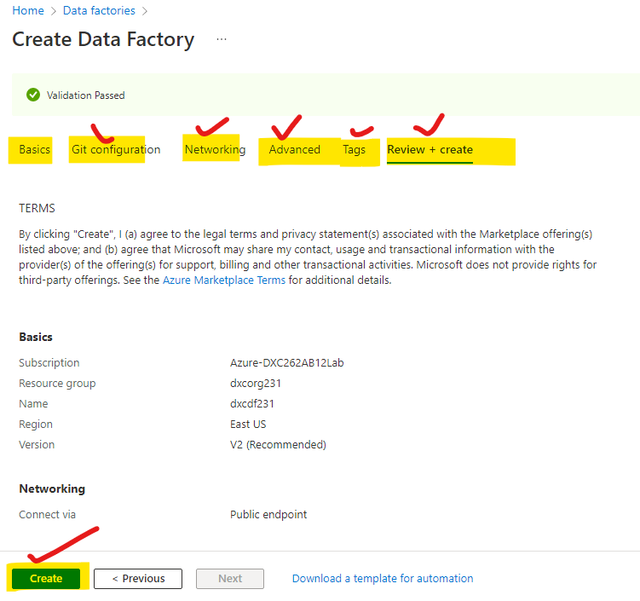

Step-6: wait it for deployment. and once its is done

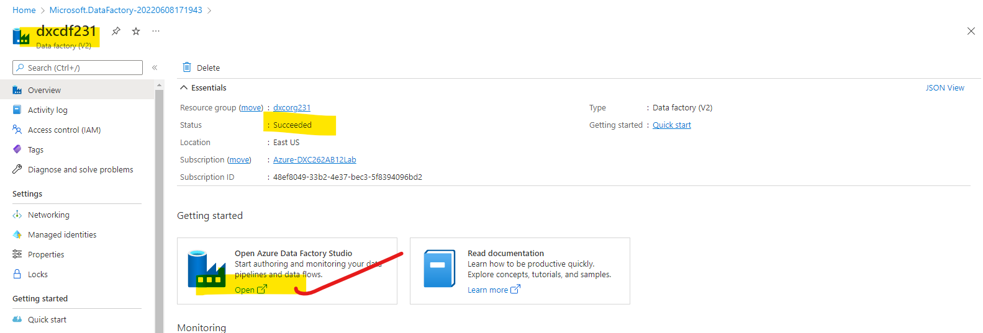

Step-7: after clicking on the open button the data factory window will open in new window

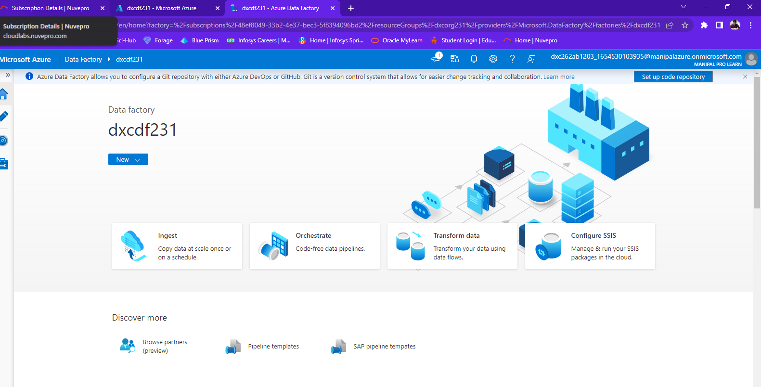

4. Explain the steps with screenshots how to copy data from source blob to destination blob ?

Ans) After creating the source blob(in my case blob name -“aditya”) and destination blob is destination

Step-1:

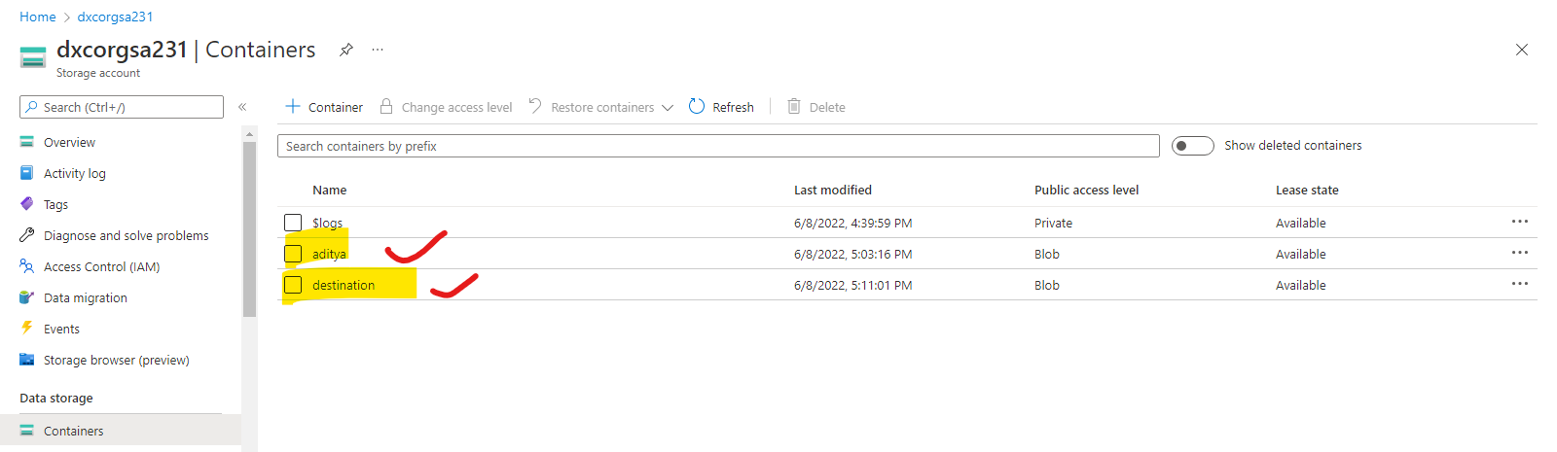

Step-2:after That open data factory click on ingest

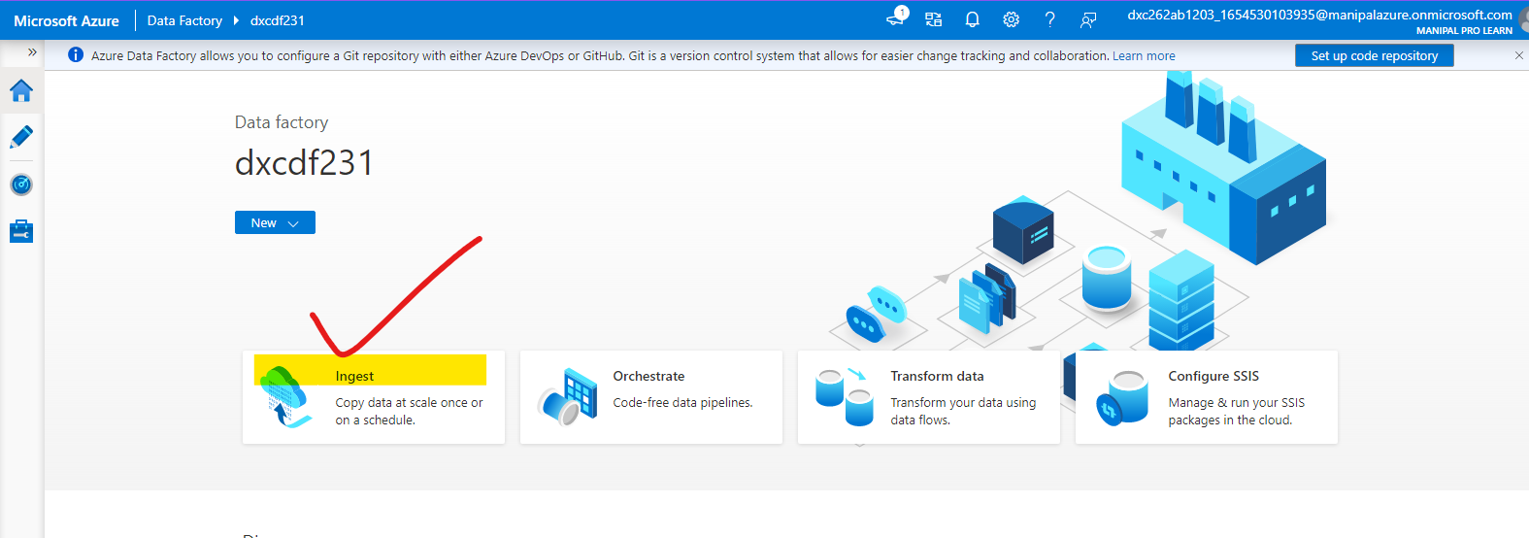

Step-3: after clicking on ingest follow these steps

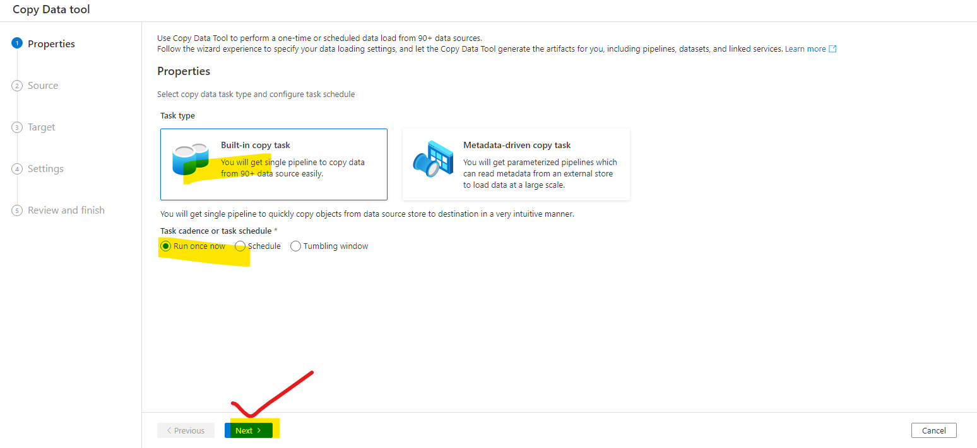

Step-4: give the data stores account location and required details for source data

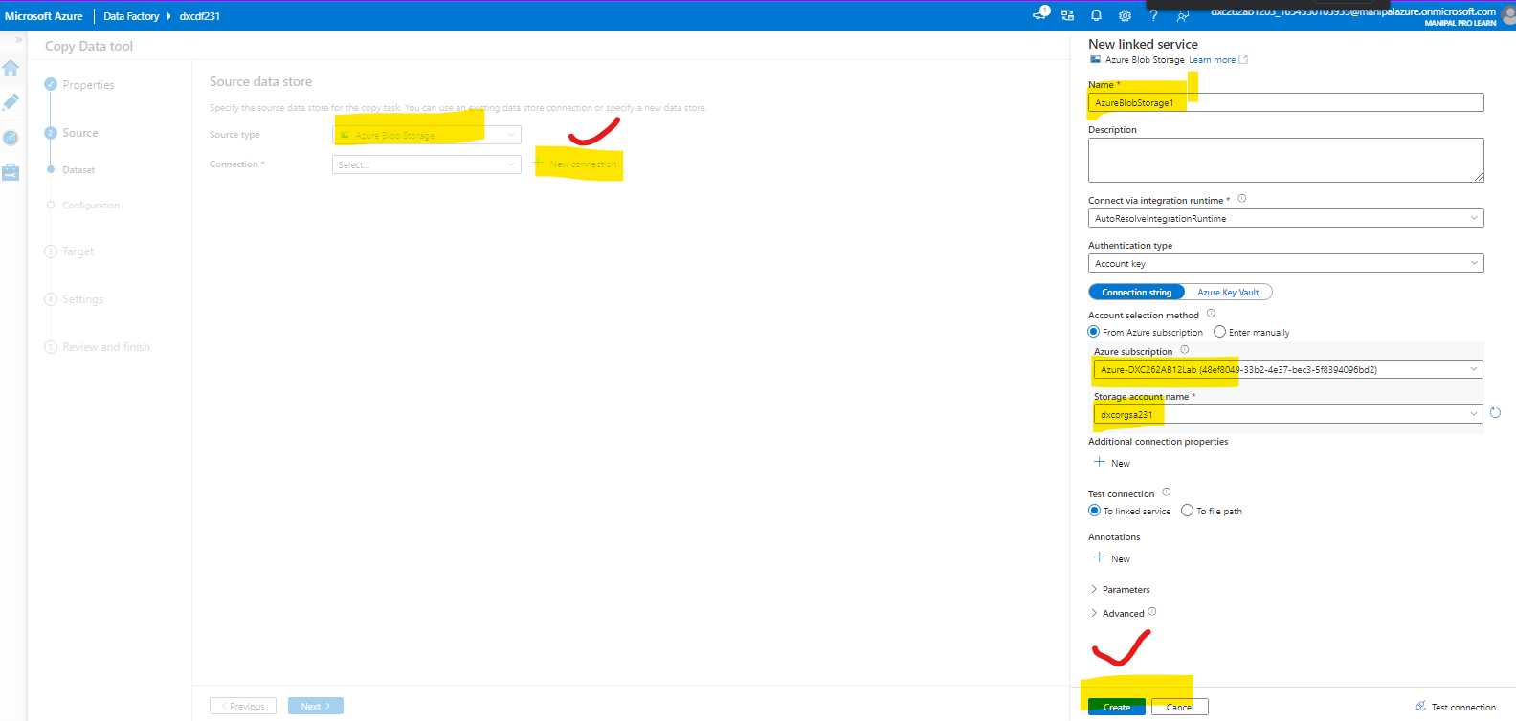

Step-5: give the data stores account location and required details for destination data

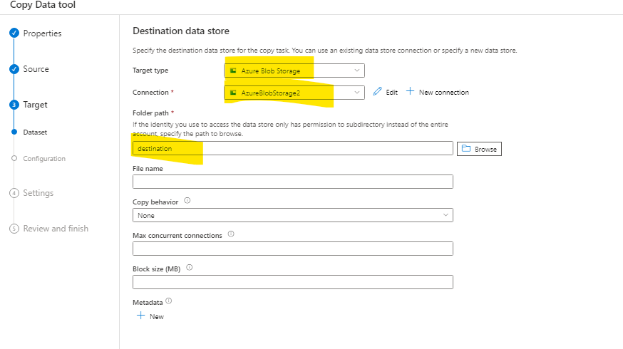

Step-6: after reviewing all the data

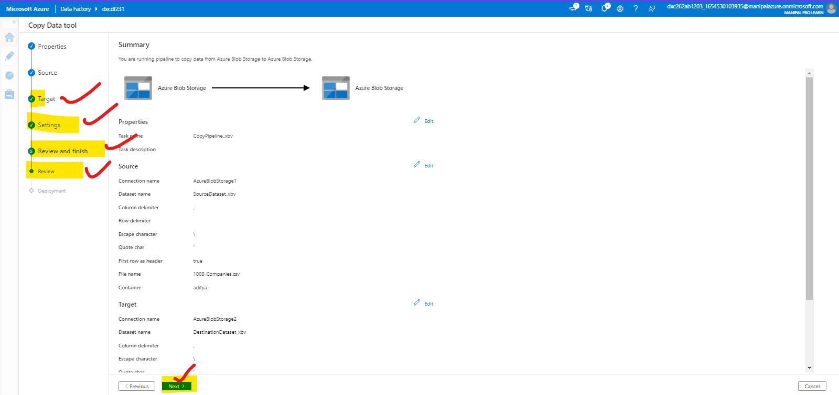

Step-6: the pipe lines are created and data is ready to transfer

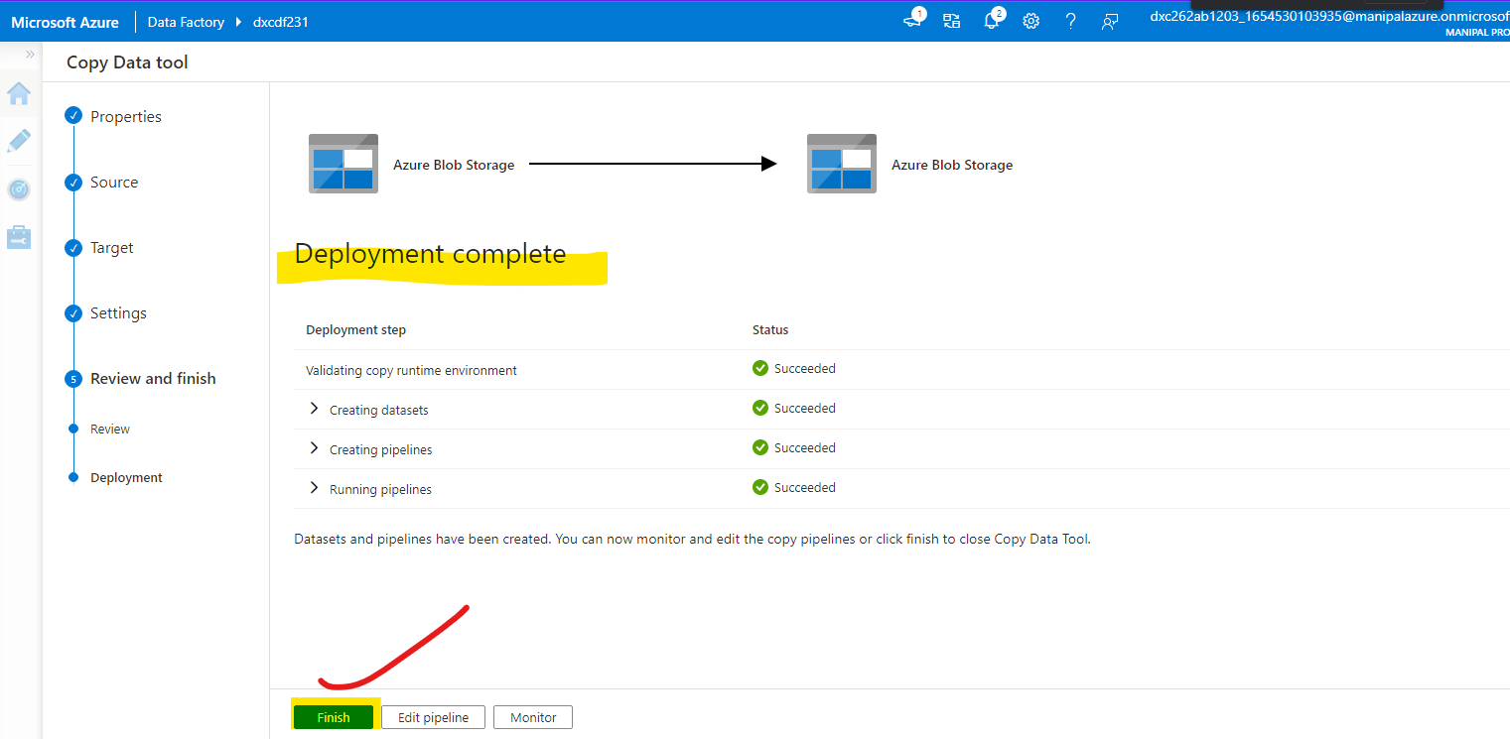

Step-7: the data is shared successfully from source to destination

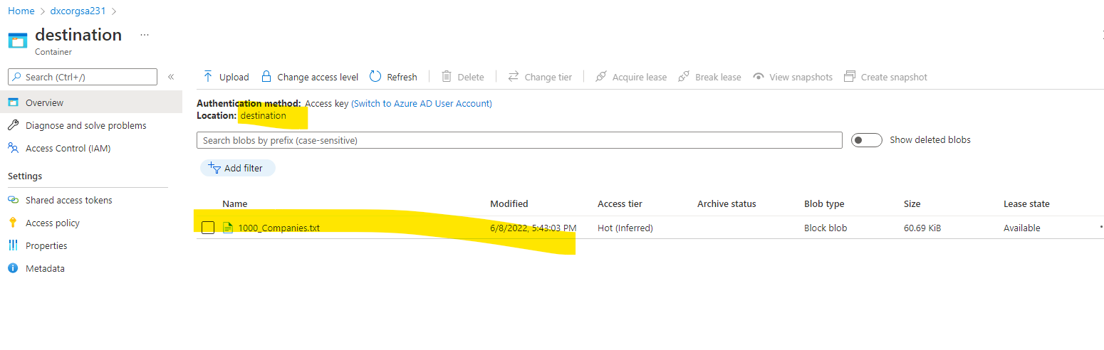

5. Explain the steps with screenshots how to create Virtual Network in Azure?

Ans)

6. Explain the steps with screenshots how to create azure synapse analytics?

Ans)

Step-1:

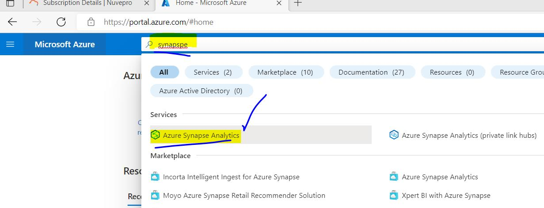

Stpe-2:

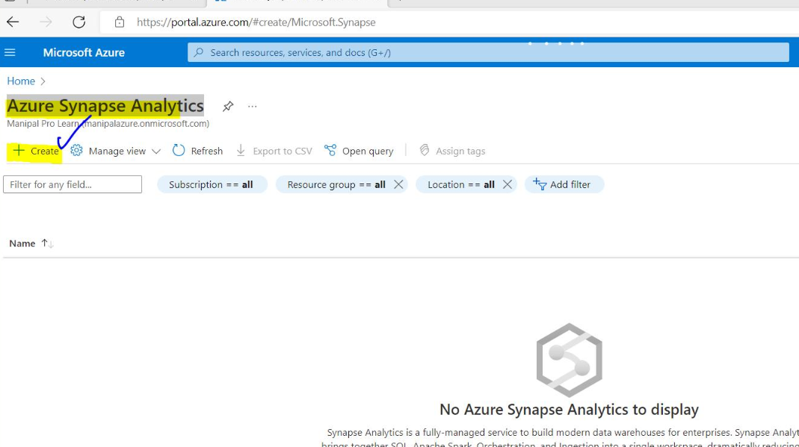

Step-3:

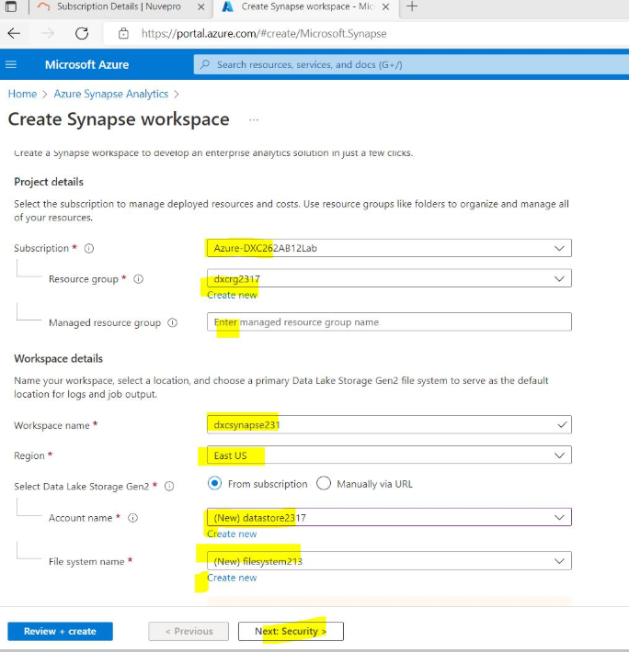

Step-4:

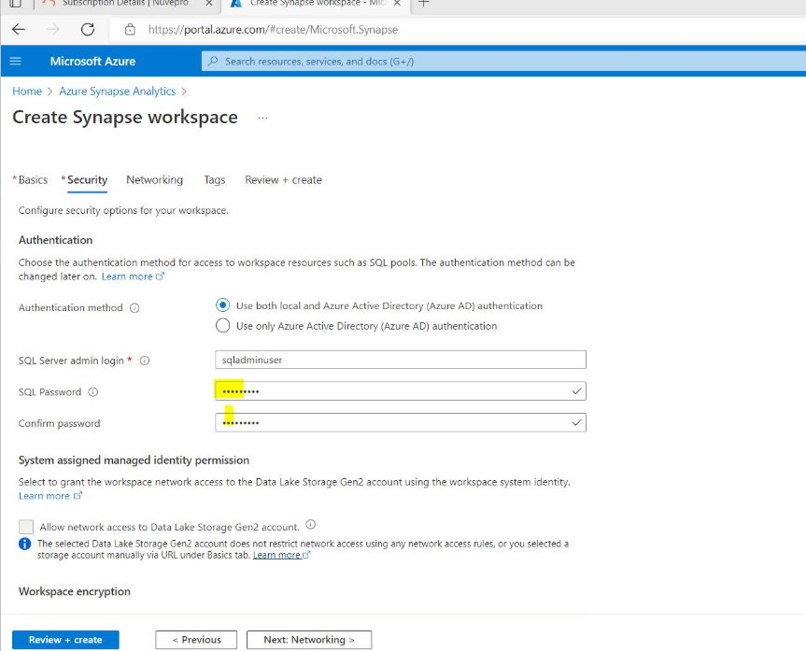

Step-5:

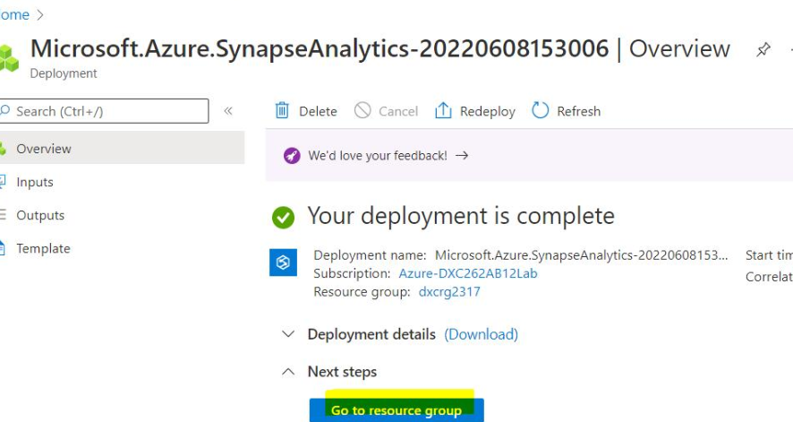

Step-6: the synapse creation is done

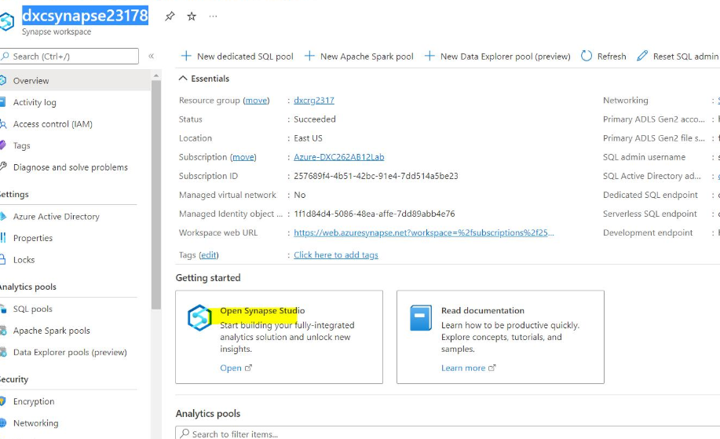7. Explain the steps with screenshots how to create Azure storage account?

Ans)

Step-1 :



Step-2:



Step-3:



Step-4:



Step-5: The storage Account is created successfully.



8. Explain the steps with screenshots how to create upload data into Azure Blobs ?

Ans) After creating the storage account the following steps should be followed

Step-1 :

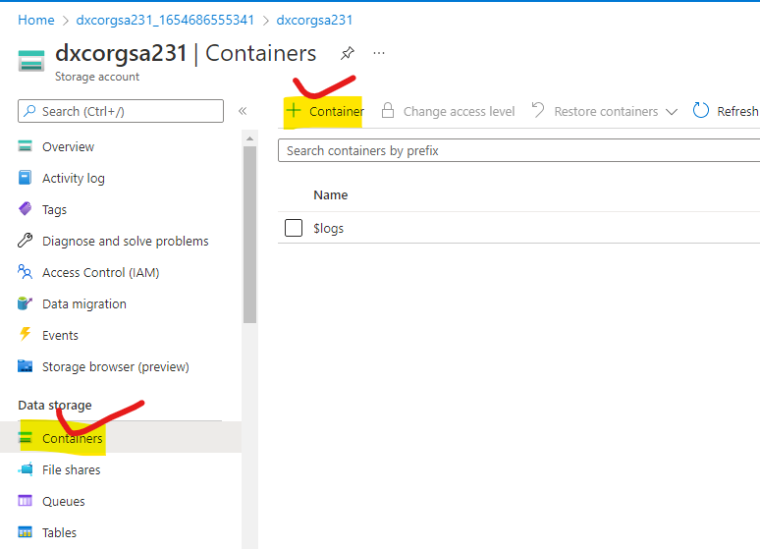

Step-2: Create a container and name it

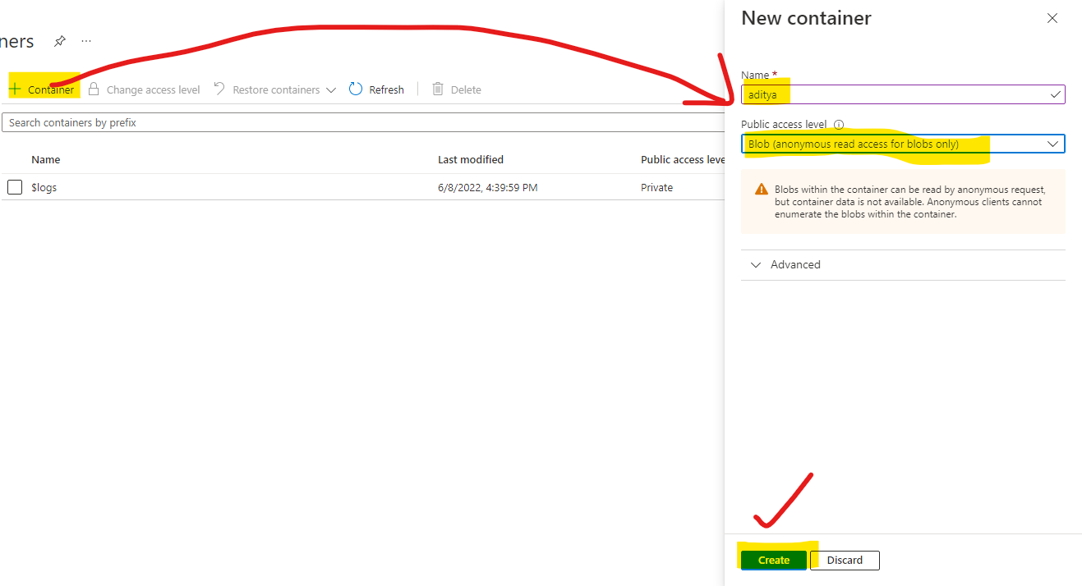

Step-3: The blob will be created and to upload the data into it follow the steps

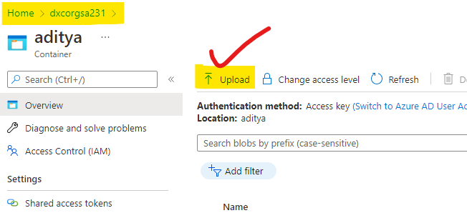

Step-4: upload the file by browsing from the file explorer

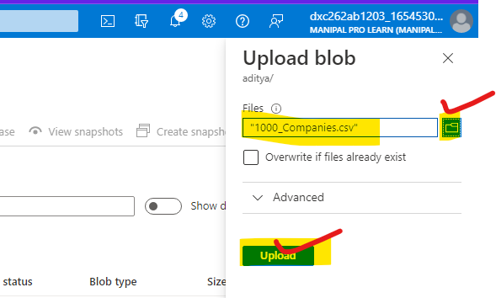

Step-5 : the data will be uploaded successfully

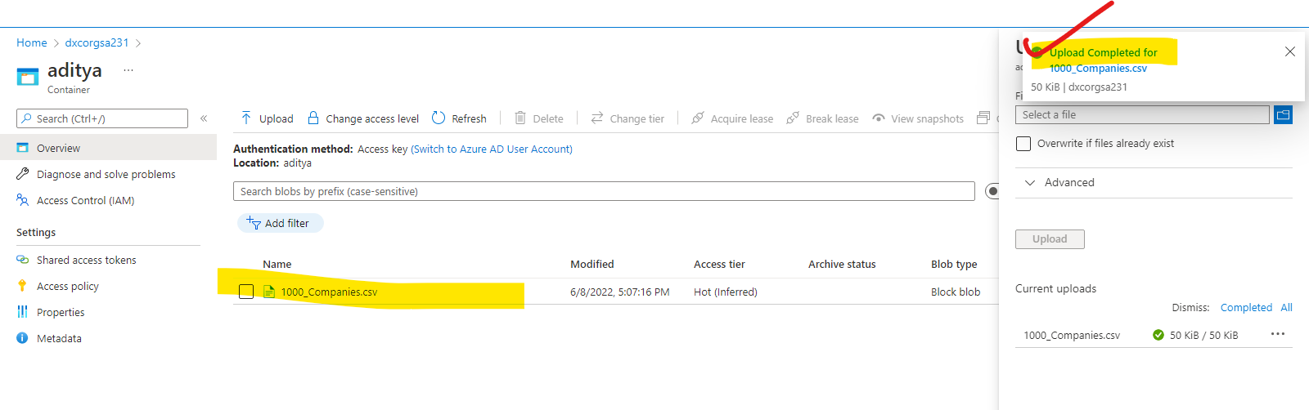

9. Explain the steps with screenshots how to create connect SQL Database in Azure ?

Ans)step-1: search for azure sql in search bar

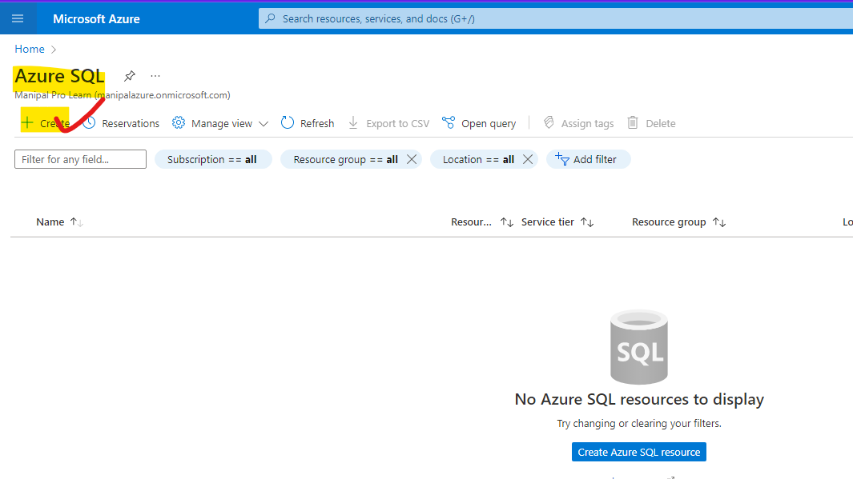

Step-2:after click on create follow the steps

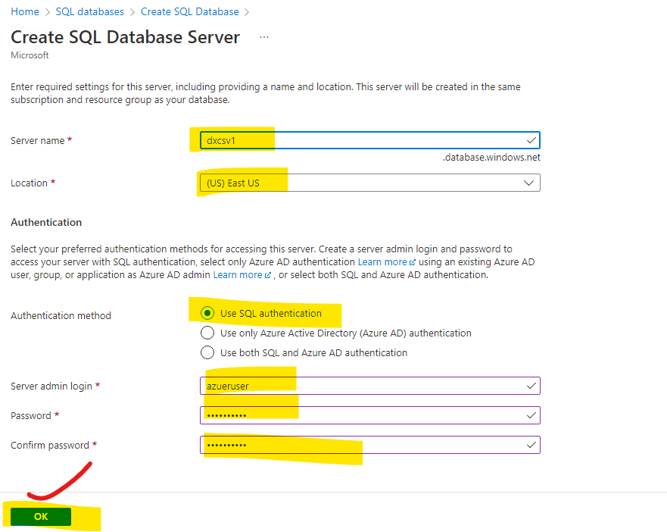

Step-3: 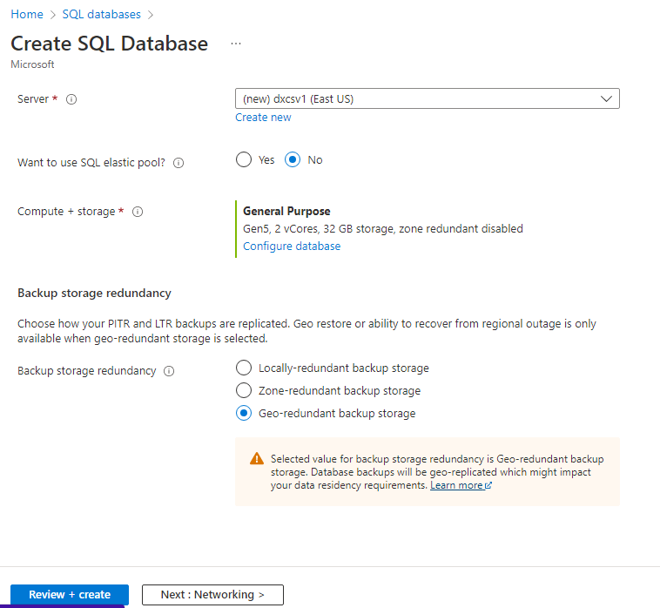

Step-4:

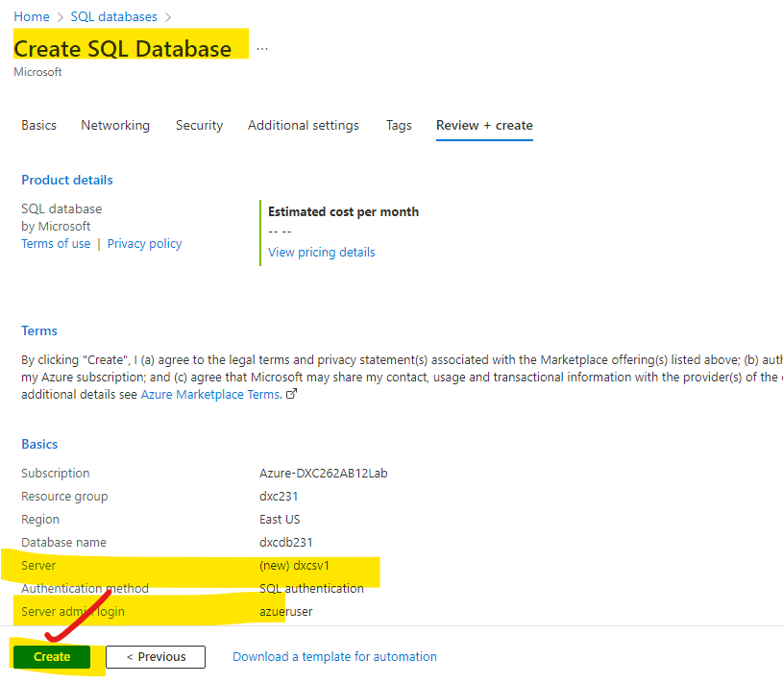

Step-5: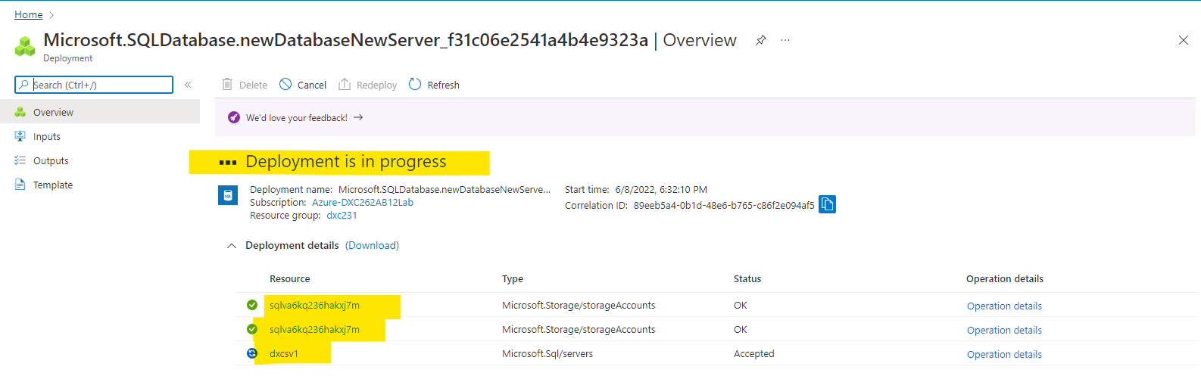

Step-6:

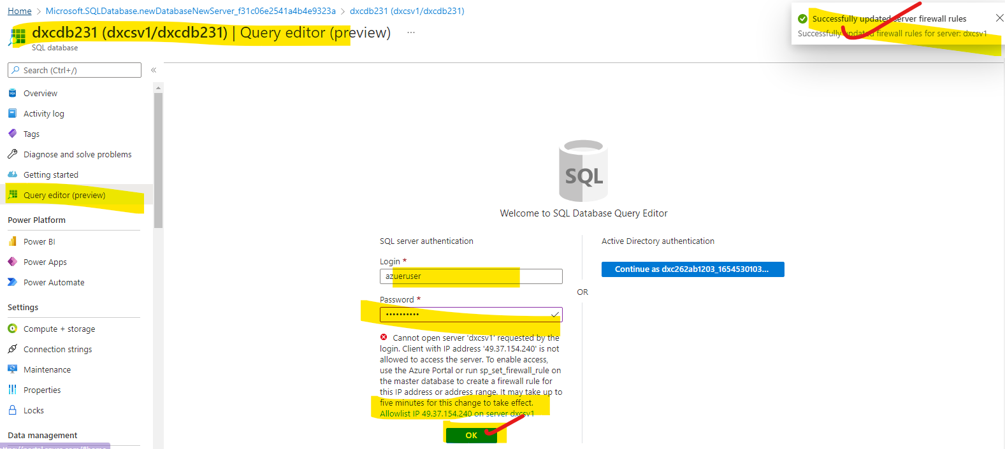

Step-7: login with the credentials and allow firewall to allow the changes and click on ok the sql database is available now

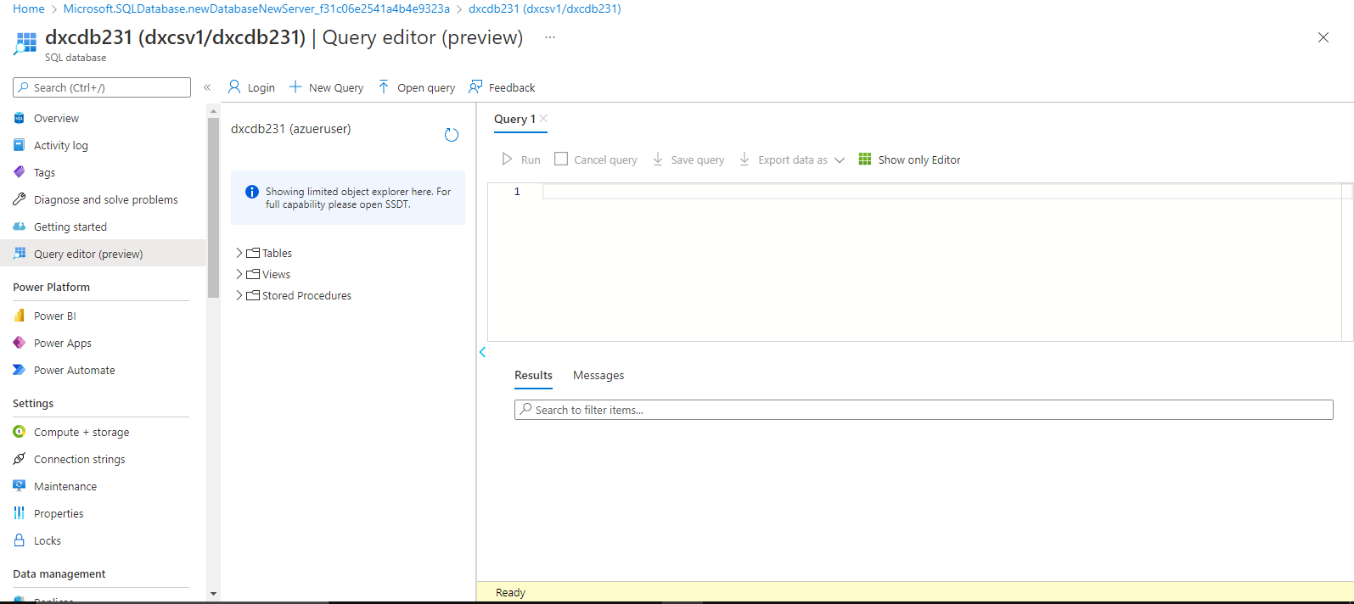

10. Explain the steps with screenshots how to insert data into azure SQL database ?

Ans) To enter the data into the data base we have to follow the steps mentioned below

Step-1: search for Azure sql databases and select the AZURE SQl databases from the search results

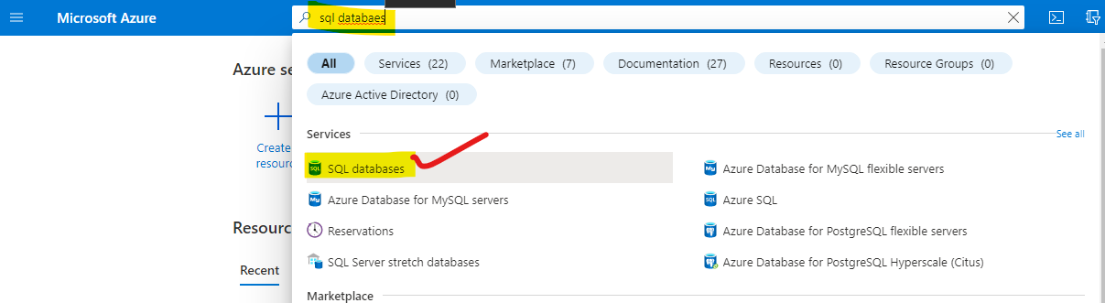

Step-2 : after selecting the Sql databases. Click on create button as shown below

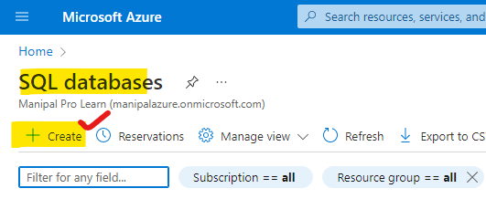

Step-3: select all options as mentioned below

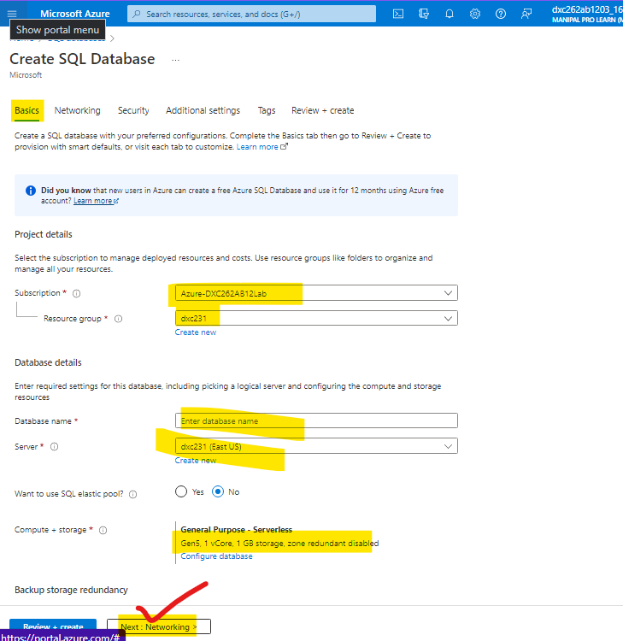

Step-4: after completing this step navigate to the next menus with out changing any settings and click on create

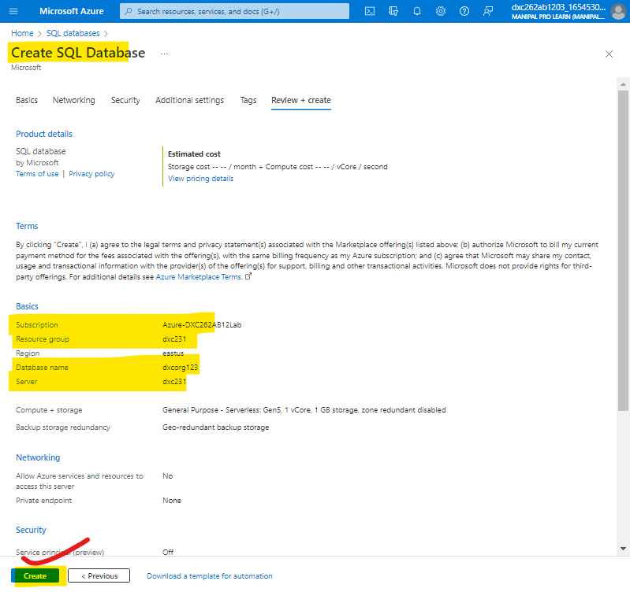

Step-5: after clicking on create it takes some time to deploy after that we can access the Database and click on query editor

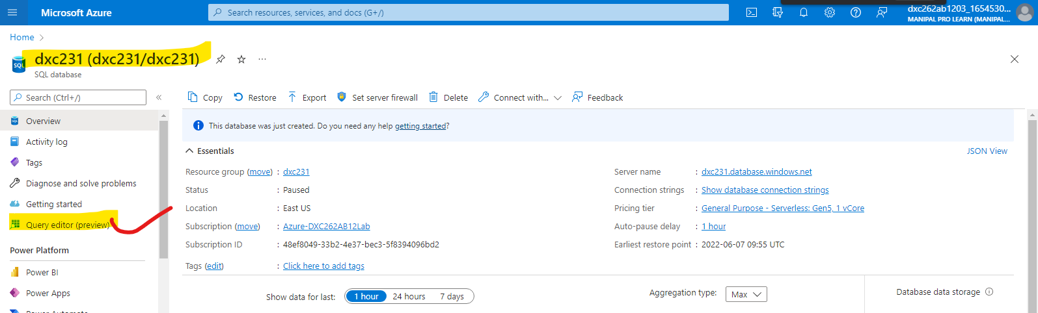

Step-6: login with your login credentials

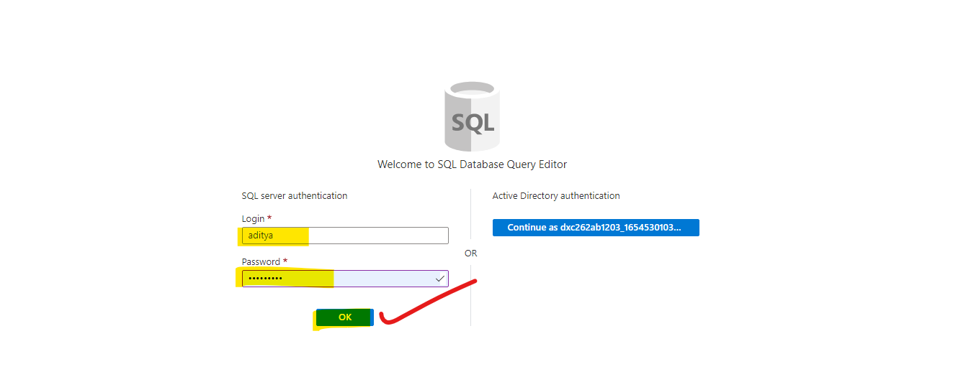

Step-7: insert the data by using the traditional SQL methods.

